The Decision to Drop the Atomic Bomb on Hiroshima and Nagasaki
Was the United States justified in dropping the Atomic Bomb?

Document 1

"I had then set up a committee of top men and had asked them to study with great care the implications the new weapons might have for us. It was their recommendation that the bomb be used against the enemy as soon as it could be done. They recommended further that it should be used without specific warning I had realized, of course, that an atomic bomb explosion would inflict damage and casualties beyond imagination. On the other hand, the scientific advisors of the committee reported that no technical demonstration they might propose, such as over a deserted island, would be likely to bring the war to an end. It had to be used against an enemy target. The final decision of where and when to use the atomic bomb was up to me.

Let there be no mistake about it. I regarded the bomb as a military weapon and never doubted it should be used."

President Harry S. Truman

Document 2

"The use of this barbarous weapon at Hiroshima and Nagasaki was of no material assistance in our war against Japan. The Japanese were already defeated and ready to surrender...

"In being the first to use it, we . . . adopted an ethical standard common to the barbarians of the Dark Ages. I was not taught to make war in that fashion, and wars cannot be won by destroying women and children."
Admiral William E. Leahy,
President Truman's Chief of Staff
In his memoirs "I Was There"

Document 3

“In the past, science has been able to provide new methods of protection against new weapons of aggression it made possible….it cannot promise such efficient protection against the destructive use of nuclear power. This protection can only come from the political organization of the world….
**document 3, cont.**
The military advantages and the saving of American lives achieved by the sudden use of atomic bombs against Japan may be outweighed by the ensuing loss of confidence and by a wave of horror and repulsion sweeping over the rest of the world and perhaps even dividing public opinion at home. From this point of view, a demonstration of the new weapon might best be made….

The best possible atmosphere for the achievement of the international agreement could be achieved if America could say to the world, ‘You see that sort of weapon we had but did not use.’”

Report from the Committee of Social and Political Implications (a group of scientists working on the Manhattan Project) June 1945.

Document 4

"The view where a moment before all had been so bright and sunny was now dark and hazy. What had happened? All over the right side of my body. I was bleeding my private nurse set about examining my wounds without speaking a word. No one spoke. Why was everyone so quiet? The heat finally became too intense to endure. Those who could fled; those who could not perished.

Hiroshima was no longer a city but a burned-over prairie. To the east and to the west everything was flattened. The distant mountains seemed nearer than I could ever remember. How small Hiroshima was with its houses gone."

Michihiko Hachiya
Hiroshima Diary: The Journal of a Japanese Physician August 6 - September 30, 1945

Document 5

“The question of whether the bomb should be used in the war against Japan came up for discussion. Mr. Byrnes did not argue that it was necessary to use the bomb against the cities of Japan in order to win the war. He knew at that time, as the rest of the Government knew, that Japan was essentially defeated and that we could win the war in another six months. At that time, Mr. Byrnes was much concerned about the spreading of Russian influence in Europe. . .Mr. Byrnes' concern about Russia I fully shared, but his view that our possessing and demonstrating the bomb would make Russia more manageable in Europe I was not able to share. Indeed, I could hardly imagine any premise more false and disastrous upon which to base our policy, and I was dismayed when a few weeks later I learned that he was to be our Secretary of State.”

Leo Szilard, “A Personal History of the Bomb”

Document 6

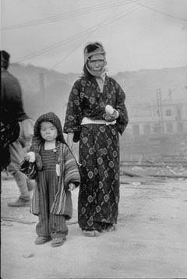
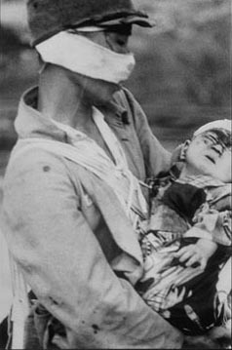
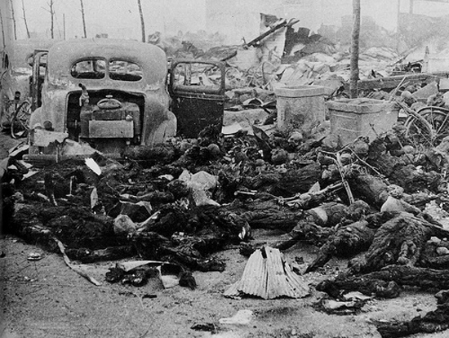

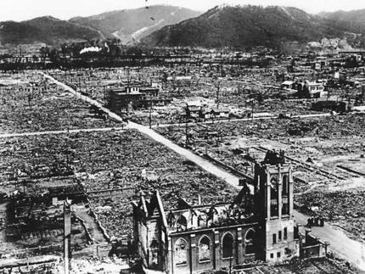

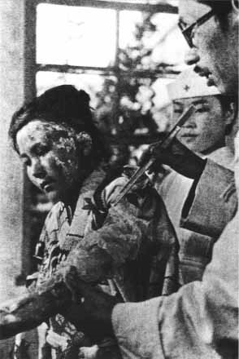
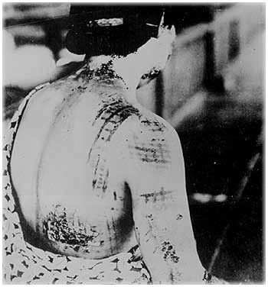

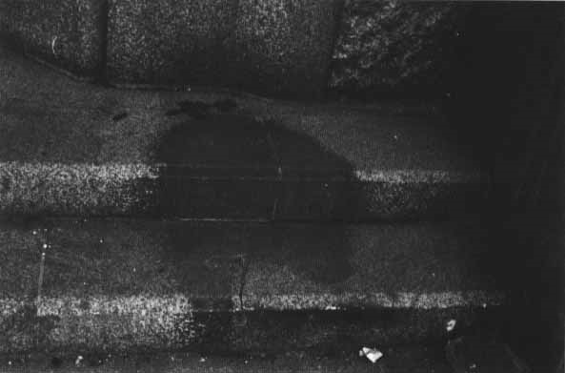

Document 7

“Another item on which I ventured to advise President Truman involved the Soviets' intention to enter the Japanese war. I told him that since reports indicated the imminence of Japan's collapse, I deprecated the Red Army's engaging in that war. I foresaw certain difficulties arising out of such participation and suggested that, at the very least, we ought not put ourselves in the position of requesting or begging for Soviet aid. It was my personal opinion that no power on earth could keep the Red Army out of that war unless victory came before they could get in.”
Dwight D. Eisenhower
Crusade In Europe, 1948.
Document 8

“The three main types of physical effects associated with a nuclear explosion are: blast and shock, thermal radiation, and nuclear radiation; each have the potentiality for causing death and injury to exposed persons. .

The frequency of burn injuries due to a nuclear explosion is exceptionally high. Most of these are flash burns caused by direct exposure to the thermal radiation. Finally, mention must be made of the harmful effects of the nuclear radiations. These represent a source of casualties entirely new to warfare.

It was estimated that 20 to 30 percent of the fatal casualties in Hiroshima and Nagasaki were caused by flash burns. The consequences of nuclear radiation may not appear for some years after exposure. Among them, apart from genetic effects, are the formation of cataracts, life shortening, and leukemia. . .”

Samuel Gladstone,
The Effects of Nuclear Explosion.
(Washington DC: US Atomic Energy Commission, 1962)

QUESTIONS

- (Doc 1) Why did President Truman feel that the atomic bomb had to be used against enemy targets?
- (Doc 2) Why did Admiral Leahy feel the use of the atomic bomb on Japan was unnecessary?
- (Doc 2) Why did Admiral Leahy think the use of the atomic bomb on Hiroshima and Nagasaki was morally wrong?
- (Doc 3) What is different about nuclear weapons from normal weapons?
- (Doc 3) What outweighs the fact that dropping the bomb would save American lives?
- (Doc 4) What observations did the doctor make about the effects of the bombing on his city?
- (Doc 5) According to this article, why was it unnecessary to drop the bomb on Hiroshima?
- (Doc 5) What claim about Russia does the author not agree with?
- (Doc 6) Describe the effects of the bombing, as seen in these photographs.
- (Doc 7) How did Eisenhower’s advice to the president influence the decision to drop the atomic bomb on Japan?
- (Doc 8) What are the effects associated with nuclear explosion?
- (Doc 8) What consequences are not immediately obvious?
- (Doc 8) How does this document support or reinforce what you saw in the photos from document 6?

